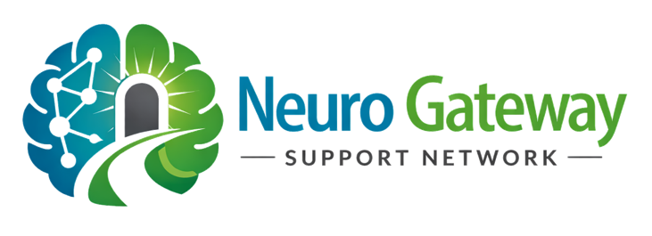
SELF REFERAL FORM

Neuro Gateway Support Network

Section 1 : Personal Information
Full Name: |  |  |  |  |  |  |  | Date of Birth:
Address:
 |  |  |  |  |  |  |  | Postcode:
Email Address: |  |  |  |  |  |  |  |  | Telephone:
Preferred method of contact:
☐ Phone ☐ Email ☐ Other:
Section 2: Individual Requiring Supported (If different from you)
Full Name:
Relation to you: |  |  |  |  |  |  | Date of Birth:
Do they consent to this referral (if applicable)?
☐ Yes ☐ No ☐ Not able to consent
If “No” or “Not able to consent,” please explain:

Section 3: About the Situation
Please provide a summary of the situation and why you are seeking support:
Section 4: Current Diagnosis (If applicable)
Has a diagnosis been made?
☐ Yes ☐ No ☐ Awaiting assessment
If yes, please specify:
☐ Dementia
☐ Alzheimer’s Disease
☐ Parkinson’s Disease
☐ Other (please specify):

Section 5: Current Support and Services Involved
Please indicate any services currently involved:
☐ GP
☐ Memory Clinic
☐ Social Services
☐ Community Mental Health Team
☐ Care Provider
☐ Hospital
☐ Other (please specify): __________________
Please provide any relevant details:

Section 6: Key Concerns / Areas You Need Help With
Please select all that apply:
☐ Understanding diagnosis pathway
☐ Accessing care or support
☐ Funding / financial support
☐ Concerns about care quality
☐ Complaints or escalation
☐ Safeguarding concerns
☐ Legal planning (e.g. LPA)
☐ Hospital discharge concerns
☐ Crisis situation
☐ Other (please specify): __________________

Section 7: Urgency of Referral
How urgent is your situation?
☐ Low – General guidance
☐ Medium – Support needed soon
☐ High – Urgent concerns
Please explain if urgent

Section 8 : Safeguarding
Are there any immediate risks to safety or wellbeing?
☐ Yes ☐ No ☐ Unsure
If yes or unsure, please provide details:

Section 7: Data Protection & Privacy Consent
I understand that Neuro Gateway Support Network will collect and process my personal data in order to provide support and guidance.

I understand that:
- My information will be handled in accordance with UK GDPR
- My data will be stored securely
- My information will not be shared without my consent unless required for safeguarding or legal reasons
I consent to my personal data being used for the purposes outlined above:
☐ Yes ☐ No
Section 8: Safeguarding & Information Sharing
I understand that if Neuro Gateway Support Network becomes aware of a safeguarding concern or risk of harm, relevant information may be shared with appropriate authorities without my consent where necessary to protect individuals.
☐ I understand and agree
Section 9: Communication Consent
I consent to being contacted by Neuro Gateway Support Network regarding my enquiry and ongoing support: ☐ Yes ☐ No
Section 10: Declaration & Consent
I confirm that the information I have provided is accurate to the best of my knowledge. I understand the role and limitations of Neuro Gateway Support Network and consent to receiving support under these terms.
By submitting this form, you confirm that:
You are requesting support from Neuro Gateway Support Network and understand that the organisation provides guidance, information, and signposting only.
You understand that:
- The organisation does not provide medical advice
- The organisation does not provide regulated legal services
- The organisation does not provide direct care services
You acknowledge that decisions made based on guidance provided remain your responsibility.
Full Name:
Signature: |  |  |  |  |  |  |  |  |  | Date:

For Office Use Only
Date Received: |  |  | Assigned to:
Initial Risk Level:
Notes:

