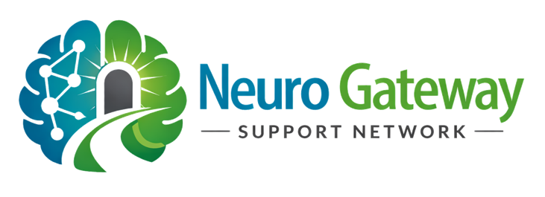
PROFESSIONAL REFERAL FORM

Neuro Gateway Support Network

Section 1: Referral Details:
Date of Referral: |  |  |  |  |  |  |  |  | Time of Referral:
Referrer Name:
Organisation / Service:
Role/ Job Title:
Contact Number:
Email Address:
Relationship to Individual:
☐ Social Worker
☐ Healthcare Professional
☐ Support Worker
☐ Family Member
☐ Other:
Section 2 : Individuals Information
Full Name: |  |  |  |  |  |  |  |  |  |  | Date of Birth:
Address:
 |  |  |  |  |  |  |  |  |  |  | Postcode:
Email Address: |  |  |  |  |  |  |  |  |  |  |  | Telephone:
Preferred method of contact:
☐ Phone ☐ Email ☐ Other:
Do they consent to this referral?
☐ Yes ☐ No ☐ Not able to consent
If “No” or “Not able to consent,” please explain:

Section 3: Individual Next of Kin ( If applicable)
Full Name:
Relation to Individual: |  |  |  |  |  |  |  |  |  | Date of Birth:
Section 4: Reason for Referral
Please provide a clear summary of why you are referring this individual:
Section 5: Current Situation and Needs
Please include relevant information such as:
- Diagnosis or suspected condition
- Current support in place
- Key challenges or concerns
- Recent changes or deterioration
Section 6: Support Requested
What support or guidance is being requested ?
Section 7: Current Support and Services Involved
Please indicate any services currently involved:
☐ GP
☐ Memory Clinic
☐ Social Services
☐ Community Mental Health Team
☐ Care Provider
☐ Hospital
☐ Other (please specify): __________________
Please provide any relevant details:

Section 8: Key Concerns / Areas Individual Need’s Help
Please select all that apply:
☐ Understanding diagnosis pathway
☐ Accessing care or support
☐ Funding / financial support
☐ Concerns about care quality
☐ Complaints or escalation
☐ Safeguarding concerns
☐ Legal planning (e.g. LPA)
☐ Hospital discharge concerns
☐ Crisis situation
☐ Other (please specify): __________________

Section 9: Urgency of Referral
How urgent is the situation?
☐ Low – General guidance
☐ Medium – Support needed soon
☐ High – Urgent concerns
Please explain if urgent

Section 10 : Safeguarding
Are there any immediate risks to safety or wellbeing?
☐ Yes ☐ No ☐ Unsure
If yes or unsure, please provide details:

Section 11: Additional Information
Section 12: Declaration & Consent
I confirm that the information I have provided is accurate to the best of my knowledge and that consent has been obtained where required. I understand the role and limitations of Neuro Gateway Support Network and consent to receiving support under these terms.
By submitting this form, you confirm that:
You are requesting support from Neuro Gateway Support Network and understand that the organisation provides guidance, information, and signposting only.
You understand that:
- The organisation does not provide medical advice
- The organisation does not provide regulated legal services
- The organisation does not provide direct care services
You acknowledge that decisions made based on guidance provided remain your responsibility.
Full Name:
Signature: |  |  |  |  |  |  |  |  |  |  |  |  | Date:

Once completed, please email this form to:
info@neurogatewaysupportnetwork.org
Providing as much detail as possible will support a timely assessment and enable us to offer
appropriate guidance and support.

For Office Use Only
Date Received: |  |  | Assigned to:
Initial Risk Level:
Notes:

